**COMPUTER NETWORKS - CSA07**

**Parthibhan .R**

**192224275**

**EXPRIMENT 1**

Configuration of Network Devices using Packet Tracer (Hub, Switch, Ethernet, Broadcast)

Github Link:-<https://github.com/parthibhan007/CSA0748-computer-network/tree/main/expriment%201>

1.Board Cast:-

Simulation :-

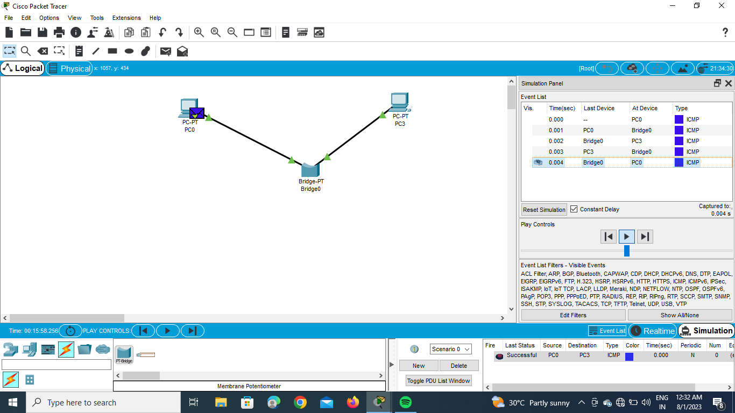

Real Time:-

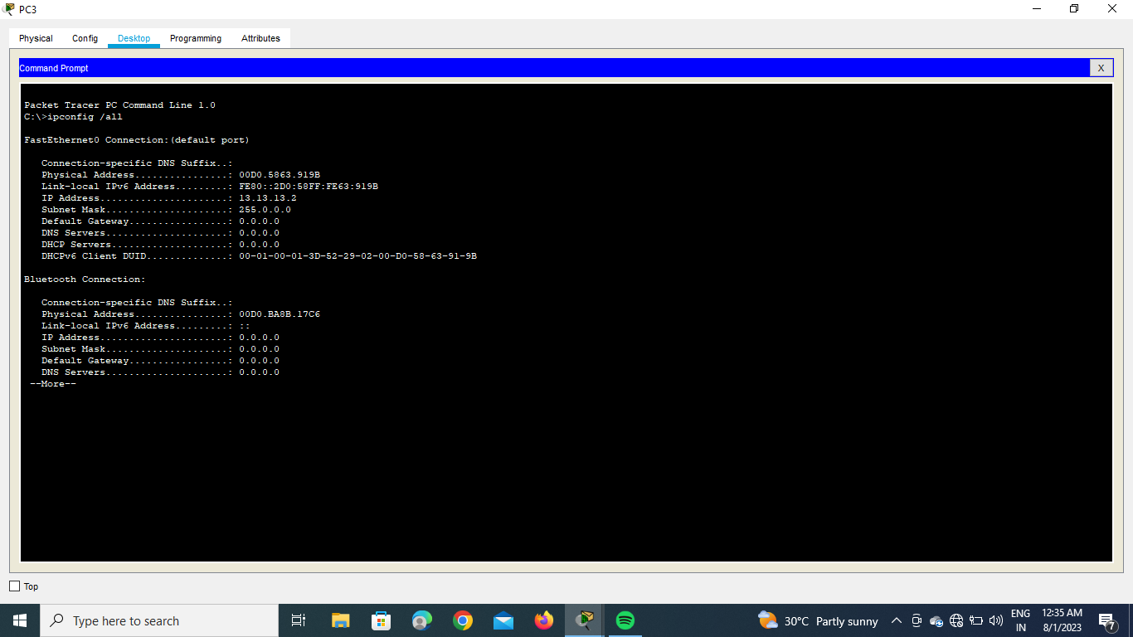



2.Switch:-

Simulation:-

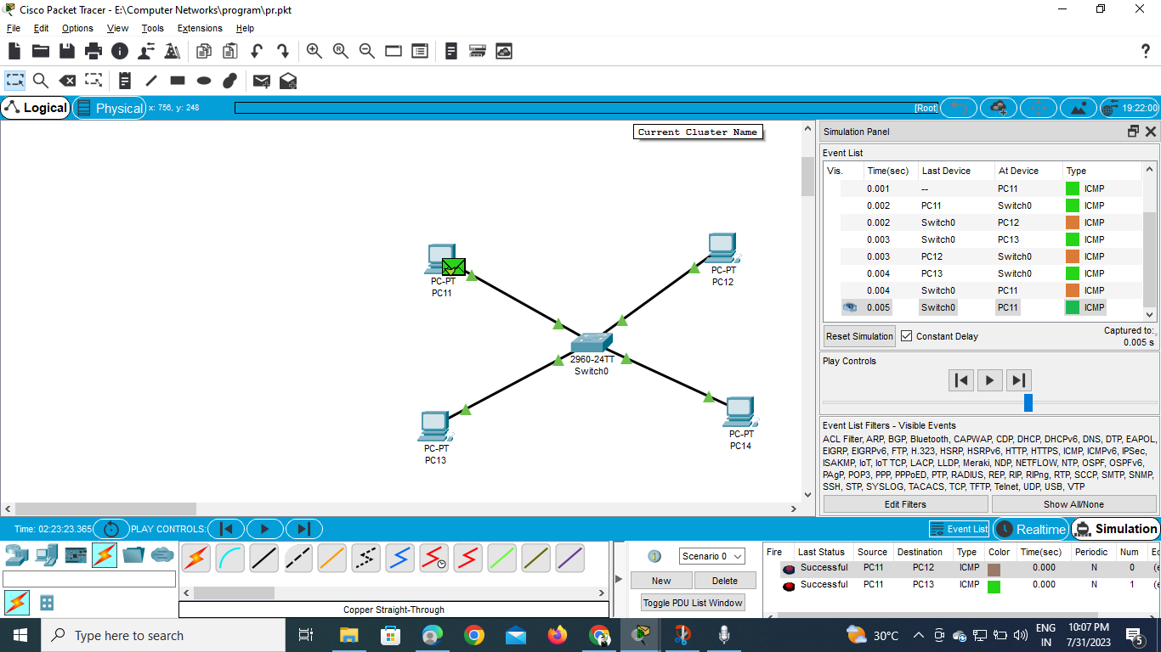

Real Time :-

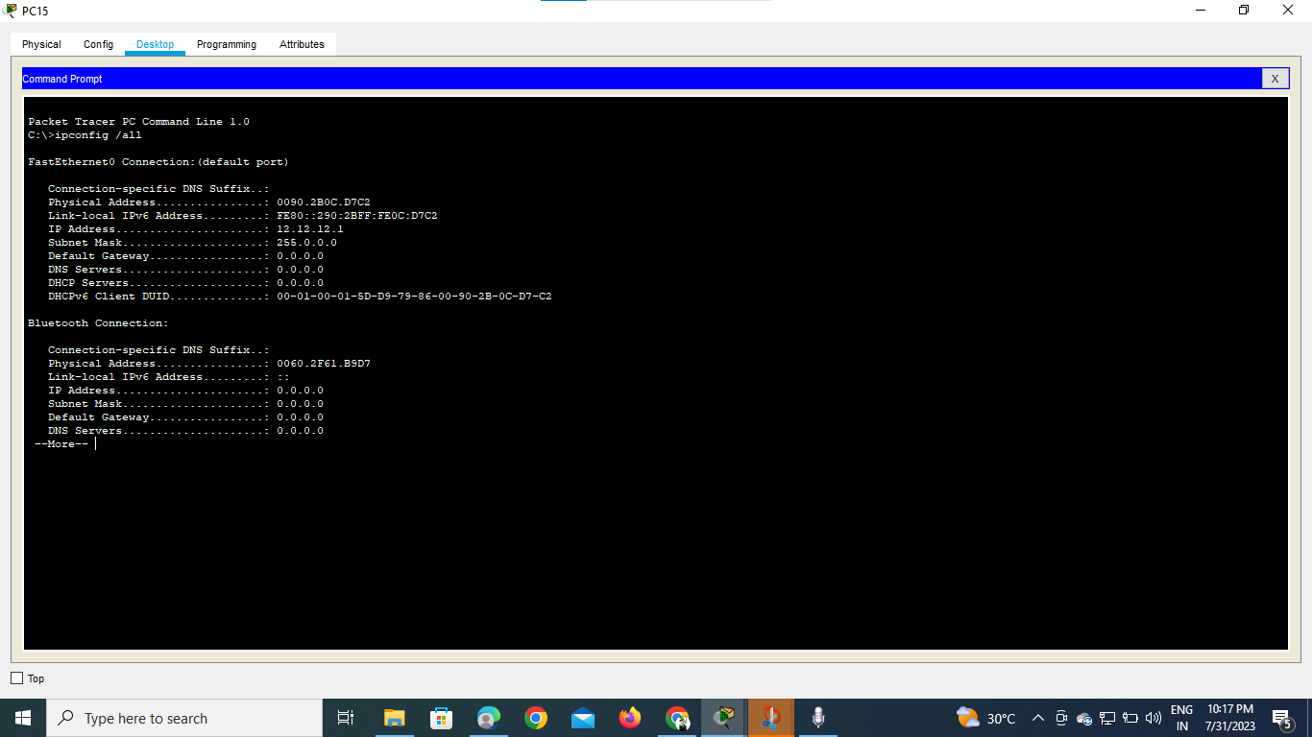

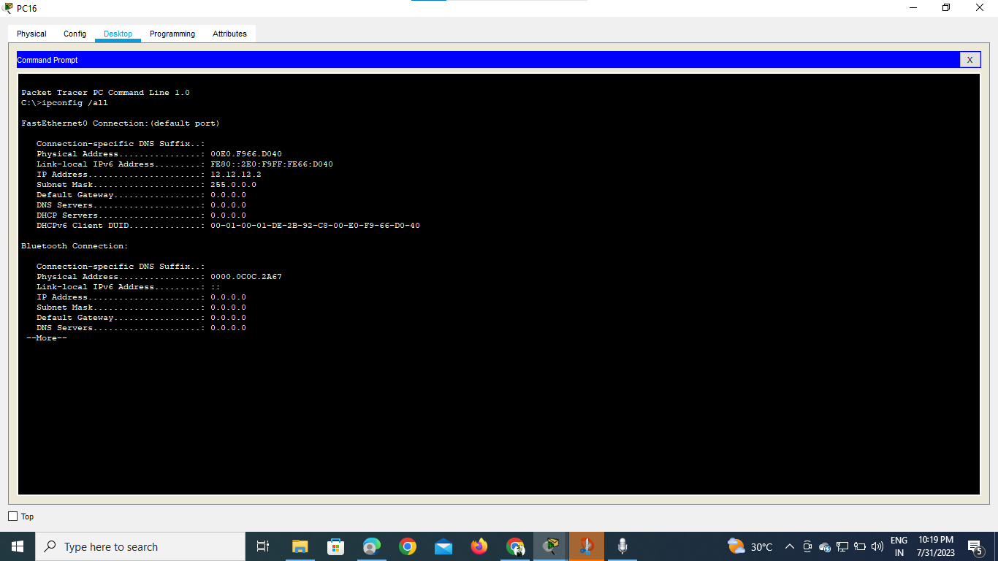

3. Hub:-

Simulation:-

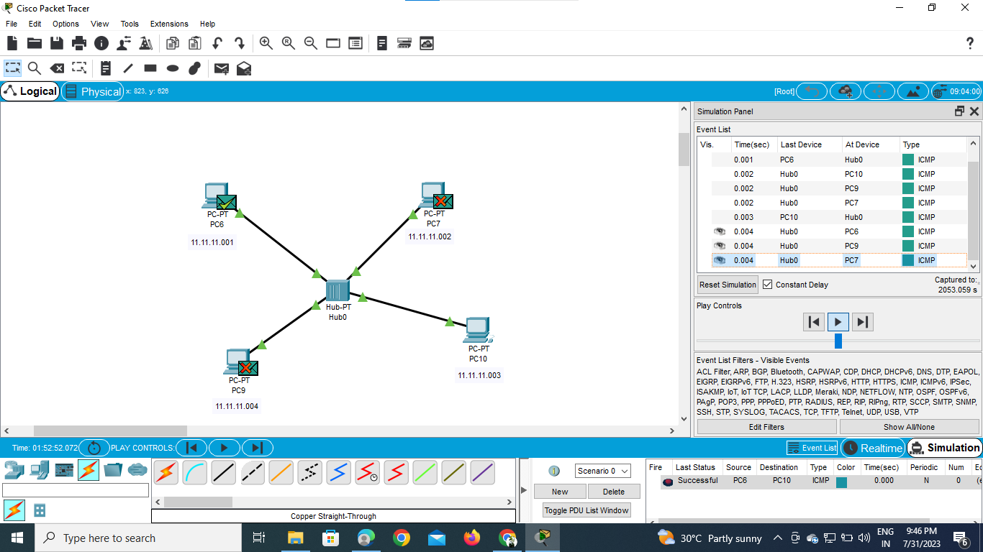

4.Router :-

Simulation:-

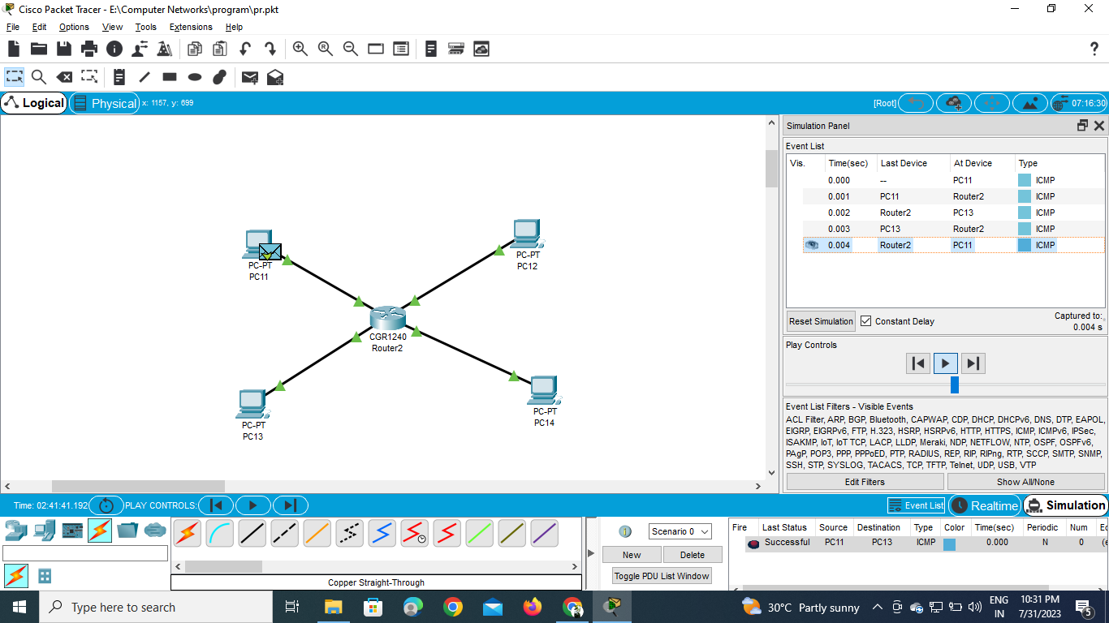

Real Time:-

